______________________________
CHOOSE SAFE PLACES
POST-DISASTER SELF-ASSESSMENT FORM
IMPLEMENTATION GUIDE

Version 3.0

Implementation Guide: Post-Disaster Self-Assessment Form

Background:

In 2016, the Agency for Toxic Substances and Disease Registry (ATSDR) released the Choose Safe
Places (CSP) for Early Care and Education Guidance Manual and began funding 25 cooperative agreements with states to begin building the CSP programs. Following the devastation of the 2017 hurricane season, ATSDR began the mission of creating the CSP Disaster Recovery Supplement to aid in the disaster recovery efforts for Early Care and Education (ECE) programs and facilities. In the fall of 2018, the Region II Head Start Association began a new project in collaboration with the National Environmental Health Association (NEHA). Through disaster recovery funding from ATSDR, these three groups are working together on this CSP initiative to help inform and educate decision-makers about the proper siting and location of ECE programs. The project is also focused on creating tools and resources that can be used in a post-disaster environment to aid recovery and minimize children’s potential exposure to toxic and dangerous hazards.

The focus of this Implementation Guide is the Post-Disaster Self-Assessment Form (PDSAF). This tool was created to help childcare providers, owners and operators assess the state of their facility post-disaster. Specifically, the PDSAF will help in the recovery process by identifying post-disaster hazards and considerations as ECEs examine whether to reopen after a disaster. It will provide ECEs with a tool to identify their post-disaster damage/needs and identify areas that can be proactively planned for and included in the ECEs disaster preparedness, response and recovery plan.

Purpose:

The purpose of this Implementation Guide is to provide an overview of the steps involved in the piloting process for the PDSAF. We want to thank you in advance for the time that you will be spending to pilot the PDSAF with early childcare professionals and local health officials in your region. While we recognize that the piloting process will take a lot of hard work, we know that what we learn from the piloting phase will help us improve the PDSAF, so that it is ready for real-world use once the next disaster strikes.

Below we provide guidance for how to collect pilot data; however, please consider a process that will work best for your jurisdiction. Because the piloting of this tool is taking place across four jurisdictions—Puerto Rico, U.S. Virgin Islands, Texas and Louisiana – we recognize that there may be variance in the mechanisms that each jurisdiction chooses to implement.

The PDSAF and the PDSAF Feedback Survey Form can be found online on the Region II Head Start Association’s webpage www.region2headstart.org/pilot

Piloting Guidelines

STEP 1: Identify Early Care and Education Programs (ECE)

Identify the ECEs that you plan to contact for the pilot. Priority ECEs for inclusion in this pilot include those that are still closed as a result of natural disasters. By selecting ECEs that are still closed, the PDSAF can be piloted with those ECEs that may most benefit from the tool. However, we recognize that contacting ECEs that are still closed may be a challenge; therefore, we also recommend piloting the PDSAF with other ECEs in your jurisdiction. Based on scientific recommendations for pilot work, the goal is to pilot the PDSAF with at least 10% of ECEs in a defined jurisdiction. When piloting the PDSAF in your jurisdiction, consider piloting within counties/cities that have been most impacted by natural disasters. For instance, in Texas, it may not make sense to pilot the tool with ECEs in the northern most region of the state.

Example: Puerto Rico
We prioritized the list of ECEs to pilot the PDSAF with by first identifying which centers are still closed. We then took a random sample of 25% of all the ECEs across Puerto Rico’s various regions (as a starting point) with the hope that at least 10% of those ECEs would agree to pilot the tool.

We strongly encourage you to work with ECE organizations to assist in connecting with ECEs. Some relevant ECE organizations are listed below. Working together with these organizations will help build a valuable partnership that will be beneficial in the piloting process and beyond. These organizations have long-established relationships with local ECEs and families. In addition, they may host conferences, workshops, trainings and other events where you may be able to conduct a pilot.

ECE Organizations:

Region VI Head Start Association
http://www.reg6hsa.org

Louisiana Head Start Association
http://www.louisianaheadstart.org

Louisiana Head Start State Collaboration
http://www.reg6hsa.org/index.php?option=com_content&view=article&id=39&Itemid=253

Louisiana Early Childhood Association
http://www.laeca.org

Texas Head Start Association
https://www.txhsa.org

Texas Head Start State Collaboration
http://www.reg6hsa.org/index.php?option=com_content&view=article&id=42&Itemid=272

Texas Association for the Education of Young Children
http://texasaeyc.org

Texas Education Agency
https://tea.texas.gov/earlychildhoodeducation.aspx

STEP 2A: Contact Early Care and Education Programs (ECE)

Once you identify the ECEs to contact for the pilot, you may wish to reach out to them via e-mail, phone call, or even in-person. Below we provide example templates for what you may wish to say to the ECE provider.

E-mail: Perhaps in your jurisdiction, you have the ECE directors’ emails and it makes the most sense to contact them via e-mail. If you do not have e-mails of the directors, then it may be better to consider using the phone to reach out to various ECEs. Consider following the below e-mail template.

Dear XX,

My name is XX and I work for XX. My organization is seeking feedback about a tool that was specifically developed for early care and education (ECE) programs. This tool, called the Post-Disaster Self-Assessment Form, was designed to help early childcare providers in making decisions and identifying issues around reopening a childcare program after a disaster. After completing this self-assessment tool, early childcare providers can use the information to work with local health authorities to determine if it is safe to reopen an early childcare program.

We would greatly appreciate any feedback that you can provide us about this tool and how we can improve it to be more useful to childcare providers such as yourself.

To review and complete the Post-Disaster Self-Assessment, please go to the following link: INSERT LINK

After completing the Post-Disaster Self-Assessment Form, we ask that you please complete the following form to provide us with feedback about the tool: INSERT LINK

We anticipate that this entire process will take approximately 30 minutes. As you review this tool, you will be asked to think back to a time when your early childcare program last experienced a natural disaster.

In doing this, we recognize that thinking back to this time period may be emotional or challenging for you. If you feel uncomfortable while completing this tool, you may end your participation at any time.
<Jurisdictions should consider adding-in information about available mental health services>

Thank you for your time and we hope that you will consider providing your valuable feedback to us about this tool.

If you have any questions, please contact me via email (INSERT EMAIL) or phone (INSERT Phone Number).

Sincerely,
XXXX

Phone: Perhaps in your jurisdiction, the easiest way to connect with ECEs is by phone. If this is the case, please consider using the following script.

Hi,
My name is XX and I work for XX. We have developed a tool that can be useful to early child education programs that are at risk for experiencing negative effects or damage as a result of a natural disaster such as a hurricane. Is your director available? I would like to talk to him/her about this tool and see if they could help us review the tool and provide us with feedback about the tool.

[If the director is unavailable, ask the receptionist for the director’s contact information and/or offer to leave your contact information as well. Then follow-up with the director at a later date].

[If director is available—describe the PDSAF to the director and ask if he/she is interested in helping us pilot the tool. [When describing the PDSAF, be sure to mention that it is a tool specifically developed to help child care owners/operators determine if it’s safe to reopen their center and that child care center owners/operators are encouraged to share the results of the PDSAF with a local health or licensing authority after completion]. If the director is interested, then thank the director and ask for an e-mail address to provide him/her with the links to the tool and the pilot assessment form. Perhaps the director is interested, but only if they can talk to you in person about the tool. Determine if going to the center with printed copies of the PDSAF and PDSAF survey is feasible. If so, then schedule a time to come out to the center to review the tool with the director and help the director complete the pilot assessment form. If the director is not interested, mark it in your notes and move on to the next ECE].

In-person: Perhaps, in your jurisdiction, the best way to collect this pilot information about the PDSAF is in-person via one-on-one interviews or focus groups. If you find that it is efficient to collect the pilot assessment data in an in-person format, contact the identified child care centers (from Step 1) and offer to come out to their centers to review the tool and complete the pilot assessment form. You may also decide that going to the child care program in-person is an option too; however, if you go in-person please note that not all child care center owners/operators will be available or interested in meeting with you that day to pilot the tool. Another possible way to collect this information is in large group settings, such as focus groups. It may be most efficient to pilot this tool by attending conferences/forums that child care owners/operators may already be attending (see Puerto Rico example below). If collecting this information in a focus group, it would be helpful to provide copies (printed or the website link) of the PDSAF to focus group participants, allow participants time to complete the PDSAF, and then allow time for participants to complete the feedback form. When completing the PDSAF feedback form in a group setting, it may be helpful for the focus group moderator to read the questions out loud, allow for discussion and then have participants report their answers directly on the form. Participants can then either enter their responses using the PDSAF survey feedback form online or complete using a paper form which is later transferred by the focus group moderator to an online form. Those moderating focus groups are encouraged to contact our project coordinator, Amy Lowery (amy.lowery@region2headstart.org), with any additional comments that arise from focus groups.

Example: Puerto Rico
One way the Puerto Rico is planning to collect the pilot data is at regional meetings with ECEs and local health officials, as well as through a Regional Head Start conference. During these meetings/conferences, time will be allocated for participants to review the PDSAF and complete the pilot assessment form. In this type of large group setting, several pilot assessments can be completed within a short period of time.

STEP 2B: Contact Health Officials and Childcare Licensing

We recognize that the rules and regulations governing the operations of early childhood programs varies widely by jurisdiction. Health officials and childcare licensing officials play an important role in helping ECEs determine if/when they can reopen their ECE post-disaster. While the tool is designed to be completed by ECEs, we are also seeking feedback from these officials on ways to improve the PDSAF.

In order to identify health and licensing officials, we recommend contacting the health department and the agency responsible for childcare licensure. This will allow you to obtain the contact information for the person(s) responsible for determining if ECEs are able to reopen post-disaster. Depending on how you select your geographic area for piloting purposes (e.g., Southeast Texas or Houston) there may only be a handful of health officials that can provide feedback on the PDSAF. We realize the number of health officials who participate in this pilot will be much smaller than the number of ECEs. As noted above, the primary audience for the pilot testing of the PDSAF are ECEs; however, we believe that health officials can provide us with useful, content-based feedback that will enable us to create the most valuable tool possible.

Entities Responsible for Childcare Licensing
In Louisiana – Department of Children and Family Services for family childcare providers
http://www.dss.state.la.us/index.cfm?md=pagebuilder&tmp=home&pid=298#undefined

In Louisiana – Department of Education – for childcare centers serving over 7 children
http://www.louisianabelieves.com/early-childhood/child-care-and-development-fund-licensing

In Texas – Health and Human Services
https://www.dfps.state.tx.us/child_care/

In Texas – a list of local childcare licensing offices
https://hhs.texas.gov/services/safety/child-care/contact-child-care-licensing

In Puerto Rico – Department of Familia
http://www.agencias.pr.gov/agencias/secretariado/Pages/default.aspx

In the US Virgin Islands – Department of Human Services
http://www.dhs.gov.vi/home/index.html

Example Scripts:

Please not that it may be best to e-mail the health or licensing official first (if the e-mail address is available) and then follow-up by phone call.

E-mail:

Dear XX,

My name is XX and I work for XX. We have developed a tool (Post-Disaster Self-Assessment Form) that can be useful to early care and education programs that have experienced physical damage as a result of a disaster, such as a hurricane.

In addition to piloting this tool with early care and education programs across the region, we are also seeking feedback from officials, such as yourself. We would like to gain a better understanding of how this tool can be useful to you in determining if an early care education program is able to be reopened post-disaster. Specifically, we are seeking your content knowledge and any suggestions you may have for improving the tool for future use.

If you can find the time, we would greatly appreciate talking with you about this tool. I would be happy to come meet with you in-person or schedule a follow-up call to review the tool with you.

The tool and the feedback form are available at the following links:
Post-Disaster Self-Assessment Form: XX
Feedback Form: XX

Thank you for your consideration.

Sincerely,
XX

Phone:

Initial contact:
Hi, my name is XX and I’m calling from XX. We have developed a tool that early care and education programs can use to assess their facilities to determine if it is safe to reopen post-disaster. While we are piloting the tool with early care and education providers, we are also seeking expert review from local officials in the region. We believe that you can help us enhance the content in the tool, as well as help us understand how this tool can be used in a real-world setting. As a local official, I am reaching out to you to see if you would be able to review the tool that we have developed and provide us with your feedback on ways to improve the tool for future use?

[If the health/licensing official agrees, offer to e-mail the links to the PDSAF and pilot assessment.]

[If the official declines this opportunity, ask if there is anyone else in their organization that you should consider contacting. Obtain the person’s contact information and directly contact the person.]

Follow-up to e-mail:
Hi, my name is XX and I am calling from XX. A couple of weeks ago, I sent you an e-mail about a tool that we are seeking feedback on. This tool was developed as a way to help early care and education programs determine if it is safe to reopen their centers post-disaster. I wanted to follow-up with you to see if you received this e-mail and if this is something that you may consider reviewing for us? We anticipate that it will not take much longer than 30 minutes to review. I would be happy to arrange a time to meet with you in-person or over the phone and discuss the tool.

[If agrees, resend the links to the PDSAF and pilot assessment form.]
[If does not agree, say that you understand and ask for the contact information of others in the organization who may be able to help review the tool. Obtain the contact information then contact the new person with the request to participate.]

Additional Information about Implementing Pilot Assessments

In this Implementation Guide, we have provided you with ideas and templates for reaching out to early care and education programs, as well as health/licensing officials, in your area to pilot test the PDSAF. The overarching goal of this pilot is to contact as many ECEs and health/licensing officials as possible in your region in order to obtain useful information that will allow us to improve the PDSAF for future use.

In order to increase the number of participants who complete the pilot, consider using a combination of the methods described above: phone, e-mail, and in-person. It may also be helpful to add information about the PDSAF and pilot assessment form to your webpage and direct ECEs and local officials to your website to download the PDSAF and complete the pilot assessment form.

Should it be useful, a printer-friendly version of the pilot assessment form is available at the following link: [INSERT LINK]. We ask that if you need to use a paper-based pilot assessment form, that you transfer the information from the paper-based form into the online form, so that the Region II Head Start Association can easily obtain the information from the pilot assessment. The Region II Head Start Association is unable to process any findings that are not transmitted to them via electronic format.

Timeline

The piloting phase for the PDSAF is from September 2019 to March 2020. In these seven months, our goal is to gather a wealth of feedback from ECEs and local officials. During this time period, we ask that you pilot the PDSAF with ECEs and health/licensing officials in your jurisdictions. All feedback from the pilot is due by March 31, 2020. Data analysis of the pilot findings will begin promptly on April 1, 2020 and a final report of findings will be available by June 30, 2020. Below is an example of the timeline used in Puerto Rico. Your jurisdiction may wish to develop its own timeline to ensure that deadlines are met, and data is provided by the March 31, 2020 due date.

Sample Timeline for Puerto Rico

Action | Start Date | End Date
Choose sample size and identify ECE still closed from hurricane | September 1, 2019 | September 30, 2019
Outreach to childcare and Head Start associations to obtain data and for collaboration on implementing the pilot | September 1, 2019 | September 30, 2019
Outreach and discussions with health/licensing officials | September 1, 2019 | November 30, 2019
Identify venues, schedules and participants for up to 5 regional meetings | September 1, 2019 | February 29, 2020
Identify ECEs that were not able to participate in regional meetings and schedule one-on-one ECE engagement | January 1, 2020 | February 29, 2020
Introduce and pilot the PDSAF at the Region II Head Start Conference | October 23, 2019 | October 25, 2019
Submit all data | Ongoing | March 31, 2020

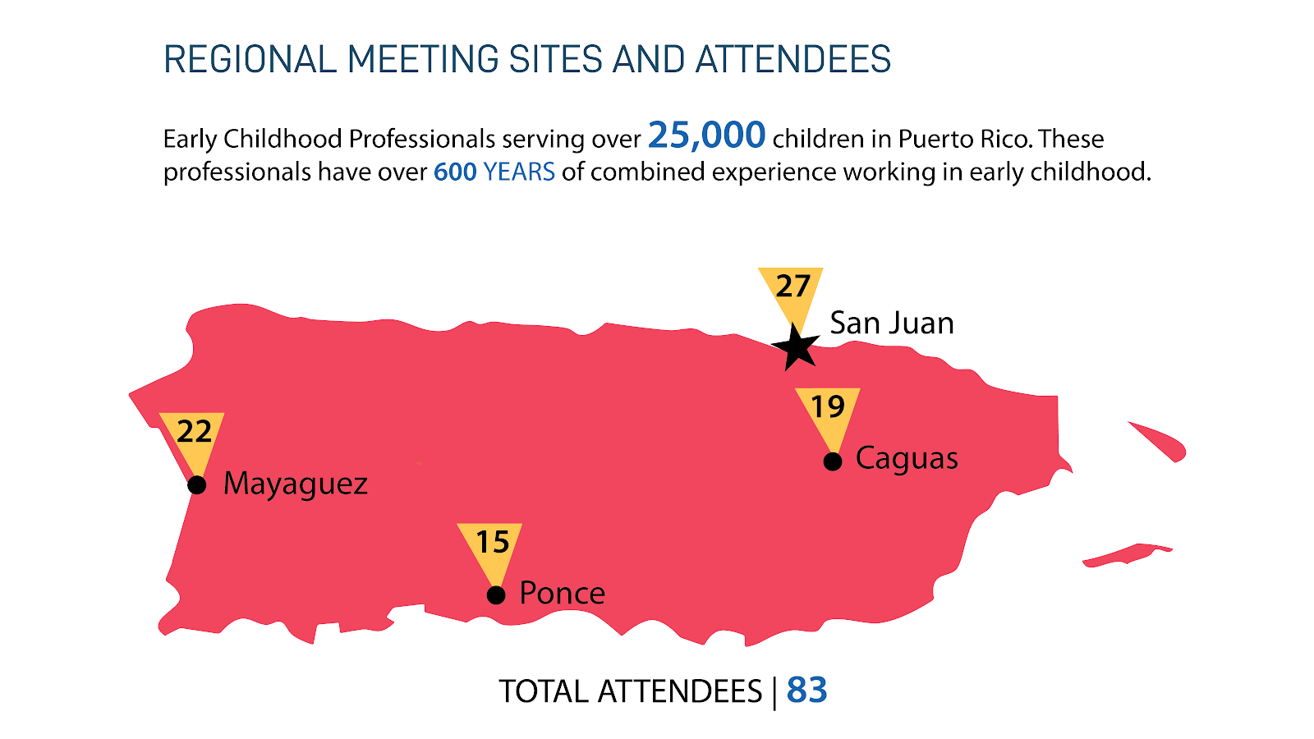
Information on the Regional Meetings conducted in Spring 2019
A full report can be found at:
https://www.region2headstart.org/post/disaster-recovery-challenges-of-early-childhood-in-puerto-rico

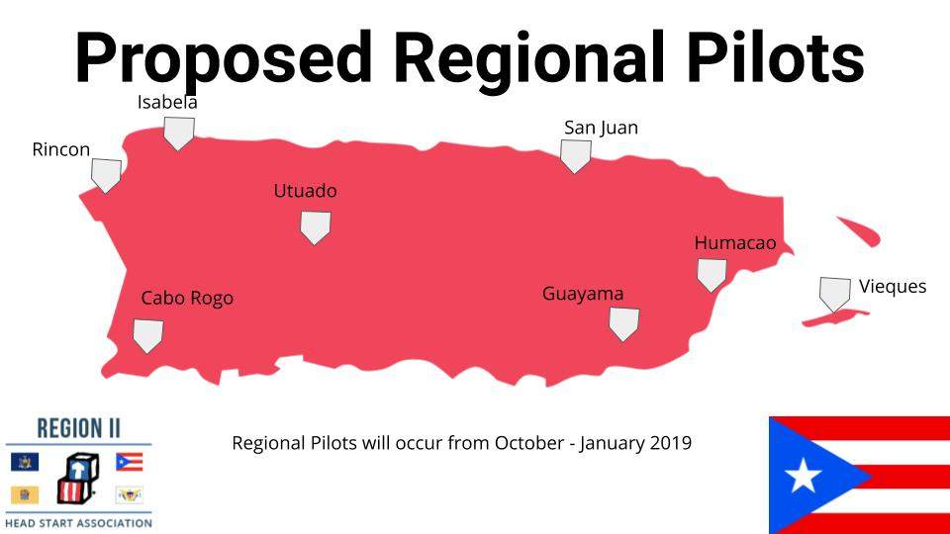

How will this information be used?

Again, we are very thankful to you for helping collect this very important pilot data from ECEs and health/licensing officials. Once we receive the data, we will analyze the data and provide recommendations for improving the PDSAF. Modifications will then be made to the PSDSAF and we will make the revised tool available. In addition, we will also develop a report of the pilot findings across all four jurisdictions. All jurisdictions involved in piloting will be provided a copy of this report when it is completed.

If during the pilot phase you have questions, please contact our Project Coordinator:

Amy Lowery at amy.lowery@region2headstart.org

Thank you!

